National Schools’ Observatory
GCSE Astronomy

Task B1: Lunar Features

Task: Produce a series of telescopic drawings and/or photographs of three lunar surface features. Use them to show their changing appearance at different lunar phases.
(GCSE Astronomy specification)

Introduction
The Liverpool Telescope (LT) can be used to image specific features on the Moon. Due to the LT field of view being very small, you would need about 49 images to cover the whole full Moon. This means that individual images show only a small area of the Moon, but show significant detail. Below is an example of what you might see in a single image from the LT, and how this compares to the overall size of the full Moon.
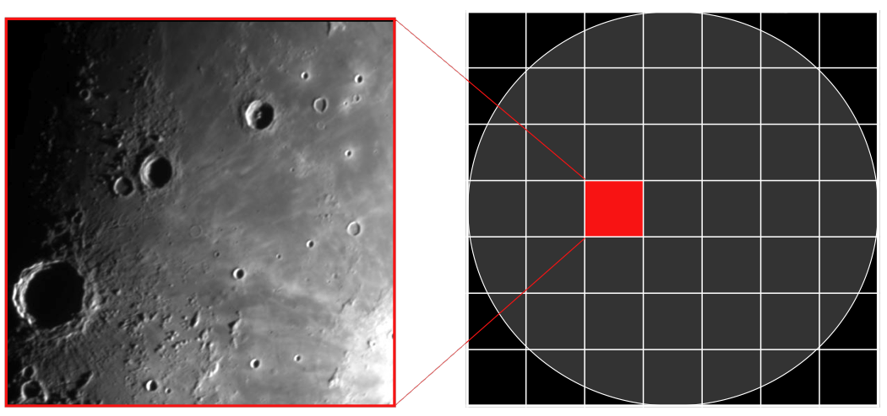

It is possible to request images of specific areas of the Moon, and this means the LT is ideal for doing this GCSE Astronomy task.

Design
To do this task, you will need to design your observing programme carefully. You will need to decide on the following things.

- the features to be imaged
- the time of month to begin observations
- the number of observations of each feature
- a time interval between observations

Observation
To adequately show how a feature changes as the phase of the Moon changes you probably need to have at least 3 images of each feature. It would be better to have more (5 would be a good number) but as you will see, this means obtaining quite a few observations. If all of your 3 features are in the same field of view (which is very unlikely with the LT) then you would only need 3 images. If you do managed to find 3 in the same field of view you would then be better off getting 5 images as this makes a better set of images to show the differences.

However, the chances are that your 3 features are going to be in different fields of view, and 3 images of each would seem a reasonable compromise. We actually recommend getting images of features that are in different fields of view. This is because the variety is useful when it comes to the analysis of your images as you will have more to write about. Sometimes a feature may not be properly visible in an image. This is OK though, as showing that it is not visible could be part of your plan.

If you are unsure how many images you need, you should check with Edexcel, NSO can only provide unofficial advice.

For each of your images full details of the observing conditions are available from the page you download your image from on the NSO website. You should document the following details for each of your observations:

- date and time
- telescope and instrument used
- observing site (precise location)
- weather conditions at the observing site
- filter and exposure time

Analysis
The task asks you to show how your chosen features change as the phase of the Moon changes. Although this could be quite obvious from the images themselves, you will need to provide some sort of written comments to explain what the images are showing. The more in-depth you can explain why the features look different, the more marks you will be able to obtain on the mark scheme. You may also get more marks if you have more images to comment on.

Although it might be enough to say that the features appear to change because the angle of sunlight reflecting from them changes, this might only be enough for basic marks. If you are able to explain why the angle of sunlight changes due to the changing relative positions of the Earth, Moon and Sun, then you are going to be able to get more marks. You could also measure the length of shadows on the Moon using LTImage and comment using figures on how the shadows change. Using numerical data is always preferred to just written comments because of the accuracy that numbers give us, and you should take care to document your images carefully and accurately including details of the date and time the images were obtained, as well as information about the images themselves (i.e. exposure, filter etc…)

Careful labeling of the major features visible in each image is important.

Mountains on the Moon make good features to choose, because at certain times sunlight only reflects from the mountain tops, with valleys being in shadow. This changes substantially over the period of a month.

Evaluation
It is more difficult to evaluate an investigation that does not have much in the way of numerical data. This is because evaluation normally requires you to comment on the accuracy of data obtained.

In this particular investigation, you could increase your chances of being able to comment on numerical data by carrying out the suggested measurements of the lunar features you selected.

This increases your chance of getting more marks in both the analysis and evaluation sections.

Things to look out for that you could comment on are:

- Quality of the obtained images
- Accuracy of the pointing of the telescopes
- The quality of the features you selected (i.e. you might now think that you could have chosen better features)
- Whether you chose the right time to start observations and the time interval between them

Further Comments
A scientific report is designed to be where you accurately communicate what you intended to investigate as well as the results of that investigation. The report is a form of communication so that others (particular other scientists) can understand what you planned to do, what results you got and what conclusions you came to when you did your analysis. As it is a form of communication you must take care to make sure your explanations are:

- Clear (using well-constructed sentences)
- Accurate (take care to say exactly what you mean, and report numerical results accurately)
- Use appropriate scientific language (make sure you use scientific terminology when appropriate, and make sure you understand the words and phrases you use so that you can use them properly)

