National Schools’ Observatory
GCSE Astronomy

Task B11: Drawings of Messier Objects

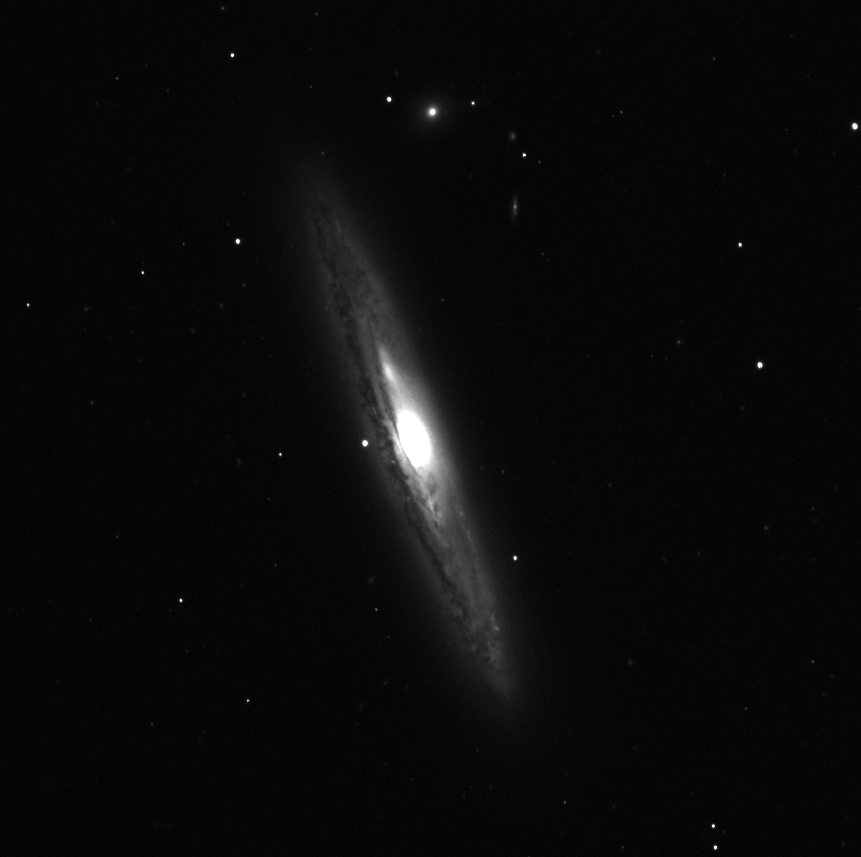
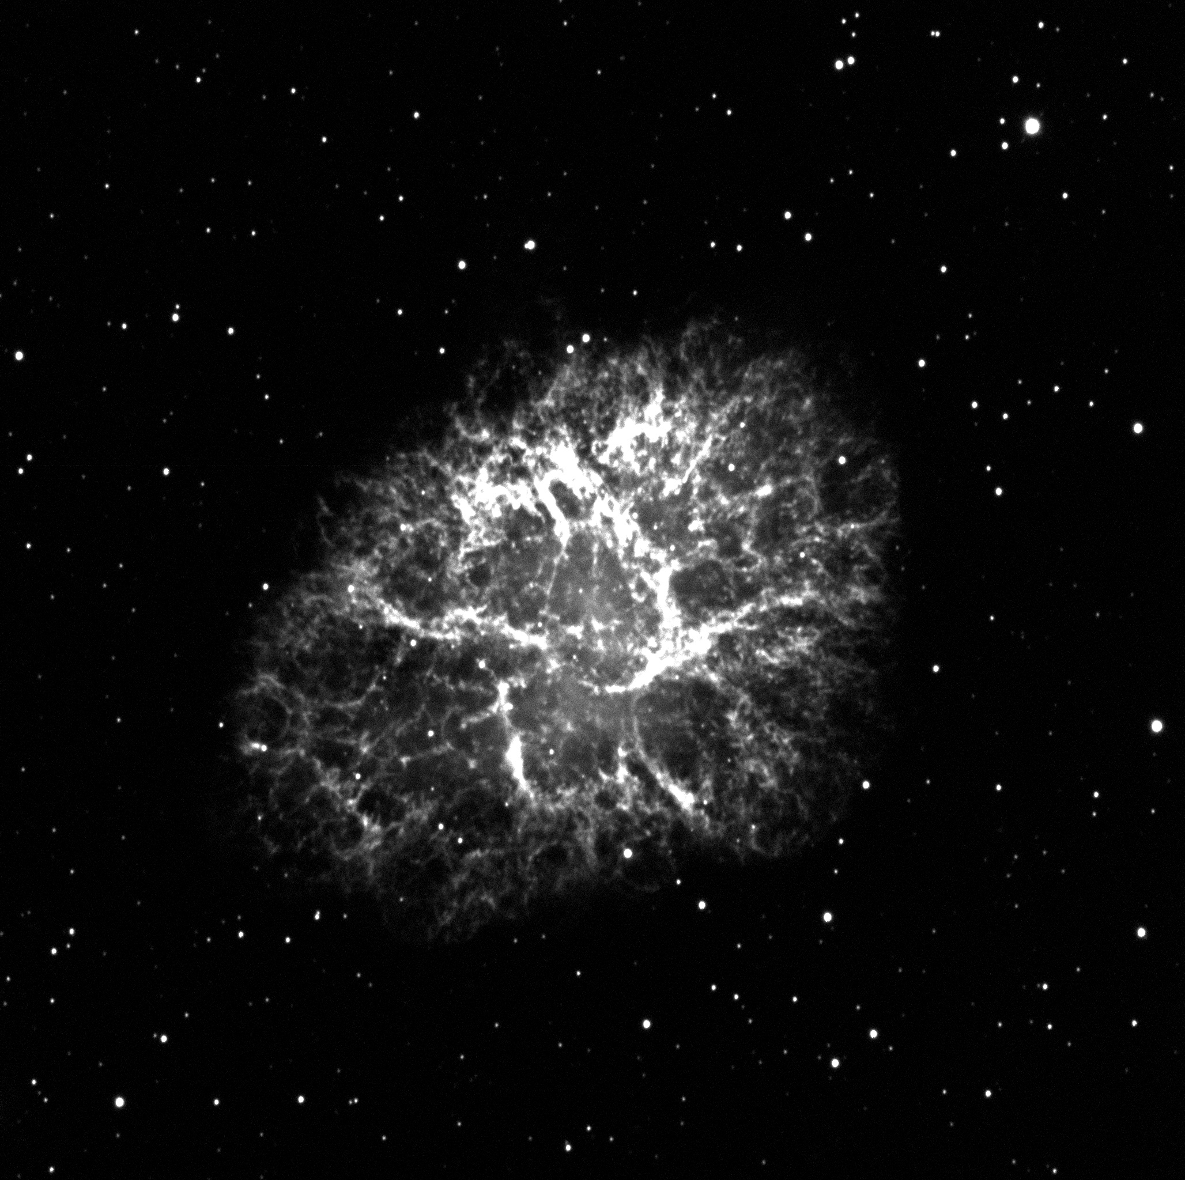

M1 - The Crab Nebula NGC 4216 a spiral galaxy

Task: Use binoculars/telescope/robotic telescope to produce detailed drawings and/or photographs of at least three Messier/NGC objects.
(GCSE Astronomy specification)

Introduction
Although the title of this task mentions “drawings” and “Messier” objects, the details of the task make it quite clear that using a robotic telescope is quite acceptable for getting photographs, and that the observations do not need to be restricted to Messier objects and can include NGC objects. Edexcel are quite keen to promote the use of robotic telescopes, and as such you should be very confident that you can use NSO for the task.

Design
To do this task, you will need to design your observing programme carefully. You will need to decide on the following things.

- the Messier or NGC objects that you will observe (minimum of three)
- when you want observations to begin
- the number of observations of each object (there is no requirement to have more than one, but it might prove useful)
- the exposure time and filter you want to use for each observation

Observation
Once your observations have been completed you will need to download them and process them with suitable software. LTImage is very suitable for this kind of image processing, but you could also use other software if you have it. Other software might include Photoshop with the FITS Liberator plugin, or SalsaJ/ImageJ amongst others.

Careful processing of the image to ensure as much detail as possible is obtained from the observations is very important for when you do the analysis of your image. You can find information elsewhere on the NSO website about how to use LTImage for image processing.

For each of your images full details of the observing conditions are available from the page you download your image from on the NSO website. You should document the following details for each of your observations:

- date and time
- telescope and instrument used
- observing site (precise location)
- weather conditions at the observing site
- filter and exposure time

Analysis
Although deciding on the objects you will observe and then processing the observations to bring out detail is very important, it is also important that you comment on what can be seen in the images. Some kind of labeling system to identify features in your images would be useful, and you might choose to comment on things that are specific to that object, or that are typical of the kind of objects your images represent. For example, an image of a galaxy such as the one above (NGC 4216), also includes stars that are not part of that galaxy. M1 (above) is a supernova remnant and the star that created this nebula is visible in the image. These are things that are significant that you could point out in your images.

If you do not want to draw on your images, you could produce some kind of overlay that shows the various features, that is attached to each image.

Evaluation
It is more difficult to evaluate an investigation that does not have much in the way of numerical data. This is because evaluation normally requires you to comment on the accuracy of data obtained.

Things to look out for that you could comment on are:

- Quality of the obtained images
- Accuracy of the pointing of the telescopes
- The quality of the objects you selected (i.e. you might now think that you could have chosen better objects)
- Whether you chose appropriate filter and exposure times for your objects

Further Comments
A scientific report is designed to be where you accurately communicate what you intended to investigate as well as the results of that investigation. The report is a form of communication so that others (particular other scientists) can understand what you planned to do, what results you got and what conclusions you came to when you did your analysis. As it is a form of communication you must take care to make sure your explanations are:

- Clear (using well-constructed sentences)
- Accurate (take care to say exactly what you mean, and report numerical results accurately)
- Use appropriate scientific language (make sure you use scientific terminology when appropriate, and make sure you understand the words and phrases you use so that you can use them properly)

