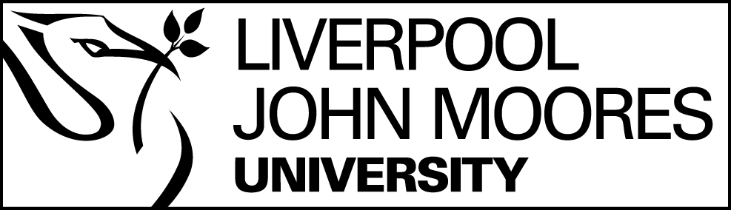
www.schoolsobservatory.org

Weight on Planets

This activity involves pupils using the NSO's Weight - Planet Calculator to investigate changes in weight on different planets.

Resources Required
The NSO's Weight – Planet Calculator
Graph paper, rulers, pencils and calculators:
- If desirable, pupils can use spreadsheet software such as Excel or Works.

Access to planetary data via the NSO Solar System Planets page.

Content
Start off by discussing the ideas of gravity and weight versus mass.
Pupils can then undertake some or all of the three activities set out below.

Classroom Activity 1
This activity involves all pupils accessing the NSO's Weight - Planet Calculator in order to look at how their weight changes on different planets.
- To start the activity every pupil must be able to work out their weight in kilograms - they may need reminding of how many pounds in a stone and how many pounds equal a kilogram. The alternative is to give the pupils a reasonable estimate for an average pupils weight, e.g. 7 stone = 45 kg, a specific animal e.g. cat = 4kg or ~9lbs.

- Pupils can input their Earth weight into the top box of the tool and then click on each planet in turn, noting down what their weight would be on each of the planets.

- A discussion of the results is required to determine on which planet they will weigh the least and on which the most. The order can be written up on the board to encourage them to see any correlation.

- With prompting, if necessary, they may come up with the idea that the smallest planet is where they weigh the least and the biggest planet is where they weigh the most. They should then be encouraged to consider the mass of the planets and compare the results.
There is not a perfect correlation in either case and this should be discussed. The discussion and search for a relationship is important in helping the pupils to develop a mathematical approach and to develop thinking skills.

- For older/more able pupils the formula: $F=G \frac{m_{1}m_{2}}{r^{2}}$ could be introduced.

Classroom Activity 2
Following on from the discussion of weight and mass - one can pose the question...
Is there less of you on another planet?
Pupils can look up the formulae connecting mass of an object with its weight:
$$Weight=Mass ×Surface Gravity$$
and use it to calculate different weights on the planets of a 50 kg object. These can be checked on the planetary weight tool.
Classroom Activity 3
If pupils have an understanding of how to draw straight line graphs they can form equations such as:
$${Weight}_{uranus}=0.79 ×mass$$
and draw W against m. By plotting all the straight line graphs on the one sheet they can see which planets have similar gravities which are greater/less than the Earth's etc.
They can consider the accuracy of the graphs by obtaining weight values for a given mass and comparing these with their calculations / computer answers. They can consider the advantages/disadvantages of each method.
If pupils are unfamiliar with y = mx + c they can plot a few values for each planetary equation to obtain the straight lines.
Extension Activities
Pupils may wish to explore the relationship of the size of the planet and its mass. This would require the use of log paper to plot the values of mass v radius. Values for mass and radius can be obtained via the planetary fact sheets listed on the NSO Solar System Planets page.
Pupils may wish to research the units of weight (Newton) and gravity (N/kg) and the incorrect usage of units in everyday life (bathroom scales etc.)
Keywords
Mass, Weight, Ratio, Graph, Algebra
Teacher’s Notes
This task gives pupils the opportunity of converting their weight from imperial to metric units, working with basic equations, creating straight line graphs and using them to convert mass into weight.
It is likely that the class will require a reasonable degree of guidance.

