Build a Bottle Rocket

Introduction:
This activity involves pupils making and launching bottle rockets. Whilst they may not realise it, they will be seeing Newton’s third law in action: “for every action there is an equal and opposite reaction”.

This activity can be great fun, but there is a need for constant adult supervision and caution. The bottles can become highly pressurised and launch at great speeds.
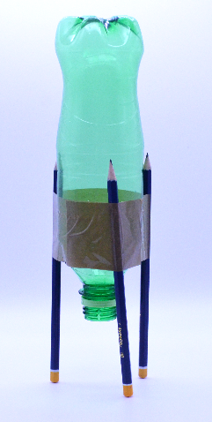
Resources:
For each rocket you will require:

- Empty drinks bottle (cap removed)
- 3 pencils
- Tape
- White distilled vinegar
- Baking soda
- 1 bottle cork
- 1 sheet of kitchen roll
- Scissors

Safety:
- Ensure adult supervision at all times
- Once the baking soda has been put in the bottle and the cork pushed in place, move away quickly and DO NOT RETURN to the rocket even if nothing appears to be happening
- If the rocket fails to launch, ensure an adult retrieves it. The likely cause is that the cork was pressed in too tight but this will mean the bottle is highly pressurised so great care should be taken in retrieving it and removing the cork
- This activity can be great fun but should be used at your own risk

We love to see your students' work! Don't forget to tag us in your posts on social media using @SchoolsObs.

