JS9 Function Manual
JS9 is a JavaScript version of the DS9 FITS viewer. It allows you to view and manipulate astronomical image data in your browser. JS9 can be run on a browser making the process easier than installing software and the inherent issues with different operating systems.

For the Citizen Science supernovae activity, you will need the “Opening Image(s)”, “Contrast Adjustment”, “Zoom” and “Photometry” sections (pages 1-5).

Opening Image(s)

Image files must be on a local drive (hard drive or USB flash drive). They cannot be pulled from an online source, like a Google Drive.

Click: File > open local file ...
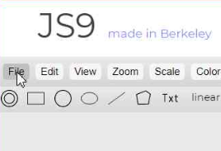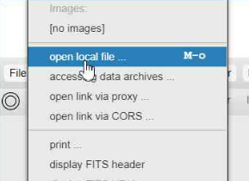

Locate the image file(s) to open. You may need to select ‘All Files *.*’ to find your image files depending on their extension.
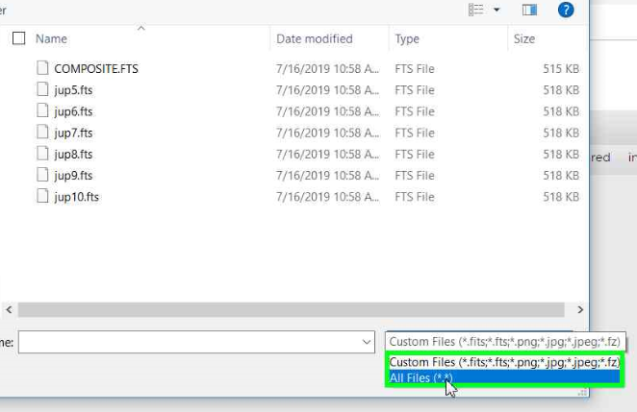

Select more than one file by using the standard ‘Control-click’ or ‘Shift-click’ method. Then click ‘Open’.

If you open more than one image, they will all be ‘gathered’ on the main screen. The first file alphabetically will be displayed on top.

Contrast Adjustment
Adjusting contrast in JS9 is incredibly easy, but can be frustrating because it is so easy, a simple accidental click will reset it!

Left click (and hold) anywhere on your image or even the gray screen on either side. Move the pointer left or right to change the contrast. You will notice the scale on the bottom of the window changing to indicate the level of contrast. Release the button to set the contrast to that setting.

TIP: Clicking on the ‘Log’ button (directly below ‘Regions’) will very often display the image without further adjustment being required.

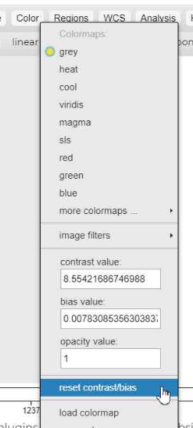
The contrast of only the active image in your window will change. To change the contrast of multiple images, you must change each image separately, OR you can do the following:
- Separate the images
- Sync the images (see directions below)
- Adjust to the desired contrast. All images will be adjusted to the same level.

You can then gather the images, if desired, retaining their adjusted contrast.

If you make color or contrast adjustments which you are unable to undo,

Click: Color > reset color/bias

to bring the image back to its original state.

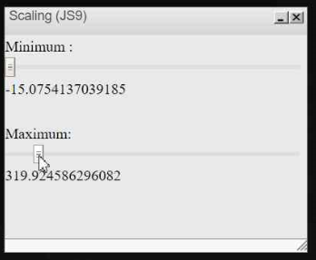
OR

Click: View > Contrast Sliders

A window labeled “Scaling (JS9)” will appear.

Adjust the ‘Maximum’ slider to the left until the desired contrast of your image is achieved. The window can then be closed.

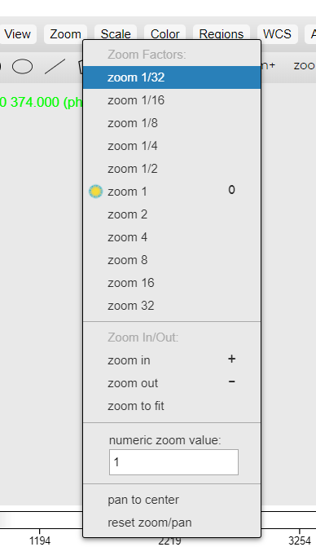
Zoom
There are a few different ways to zoom an image in or out. From the toolbar menu, there is a ‘zoom +’ and ‘zoom -’ button. The ‘zoom 1’ button takes the zoom back to the original size.
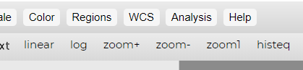

The drop down ‘Zoom’ menu allows for immediate zooming to a specific level.

Moving around the image (panner tool)
Zoomed in images will not be completely displayed in the JS9 window. You can adjust what part of the image is displayed in two different ways.

- Right-click and hold on the image. Move the image to the desired display and release.
- Select the ‘panner’ button on the tool bar. 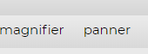
- The ‘panner’ window will open up. The green box on the image represents the displayed portion of the image on the JS9 window. Left-click and hold on the green box, move it to display the desired area of the image, then release.
- The ‘panner’ window can be closed or moved to a different part of the window using the title bar on that window.

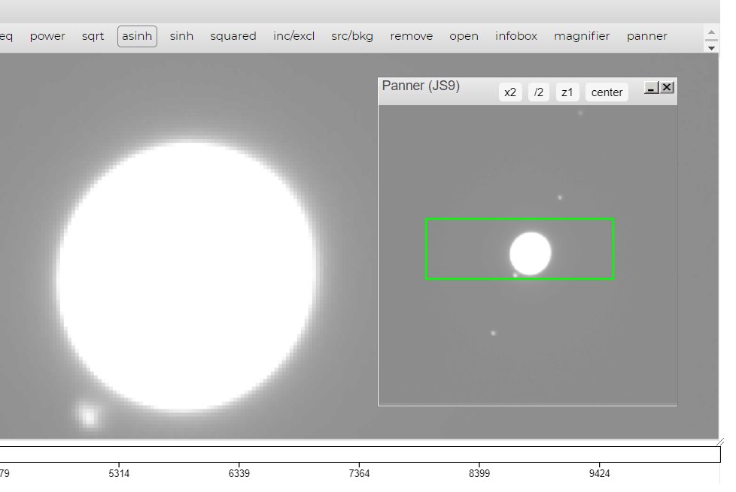

Photometry

Photometry allows you to measure a star’s brightness compared to the darker sky around it. When you create a New Annulus Region, you’ll see 3 green circles. Position the smallest circle over the star. You will be able to measure how many photons hit the CCD within this region. Between the two larger circles, it is possible to measure the sky background.

You may find it easier to operate on one frame at a time, however JS9 does allow you to perform photometry on multiple images using the following bullet points. In this instance, images should be:

- Zoomed to the same level, whichever allows for adequate selection of the stars
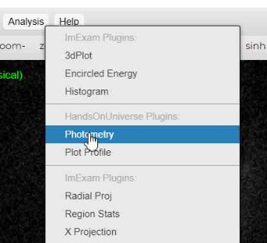
- Contrast adjusted to be able to adequately select the region of the stars
- Separated to different JS9 windows
- Turn on Magnifier (to better locate star in region)

Click: Analysis > Photometry

Move and resize the Plot Profile window to reveal the area of interest.
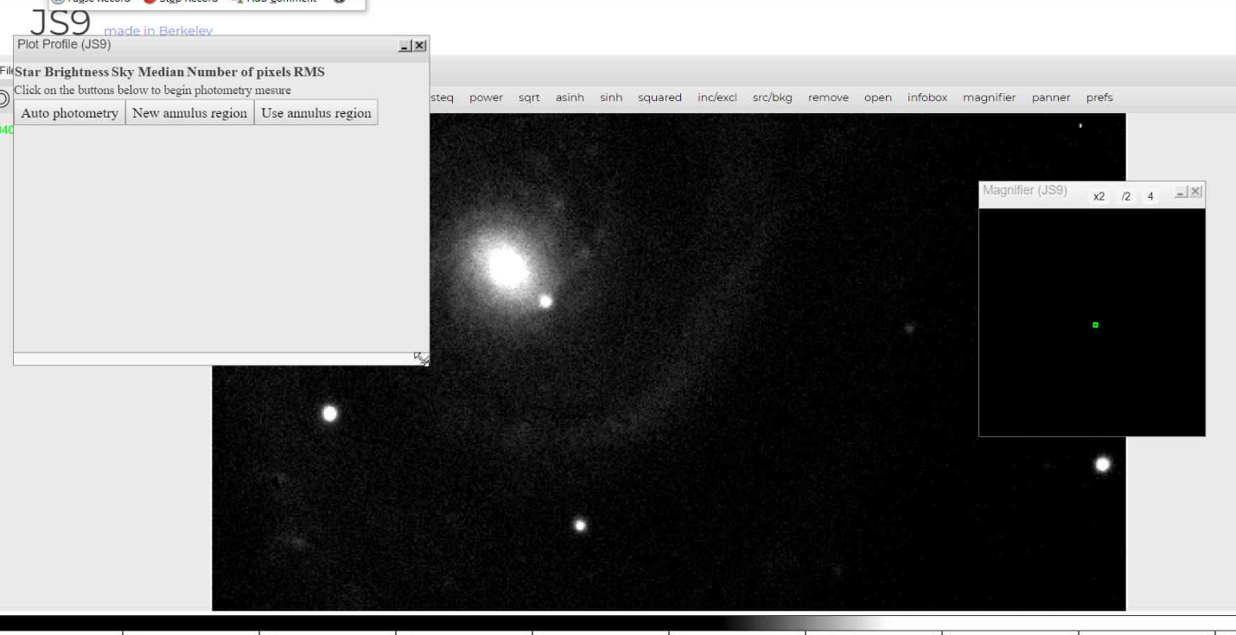

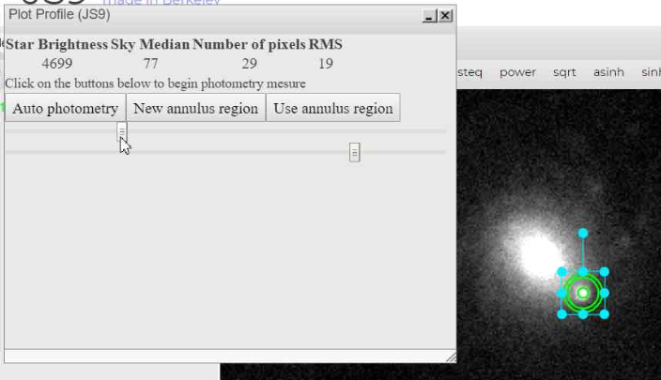
- Select “New Annulus Region”. A green triple-circle will appear. Move the centre of the circle over the star being analyzed. Use the Magnifier to help centre the region on the star.

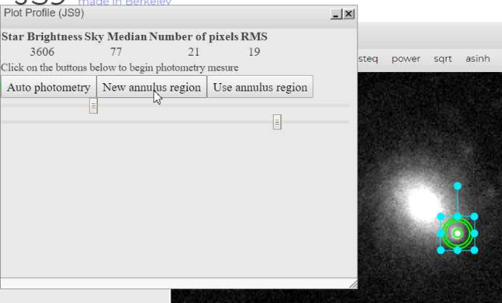
- Use the top slider to change the pixel size of the inner circle.

Choose a size standard that allows the circle to be near the size of the star. An area of 241 (roughly a radius of 9 pixels) pixels works well with images of this type.

Note that altering the contrast can appear to alter the size of the star (and the number of pixels needed).

Try to use the same number of pixels for every brightness reading (but record your
values via the Excel sheet).

Note:
- The size of the outer circle can be adjusted by dragging the blue squares on the outside of the region.
- The space between the two outer rings of the region can be adjusted by moving the lower slider to change the size of the middle circle.
- This adjustment, however, makes little change in the median sky value if there is an evenly dark sky around the star.

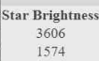
- The number under ‘Star Brightness’ represents the star brightness but also contains a contribution from the sky. The value that Excel will calculate for you
is Star Brightness – (pixels * sky median) which is a calibrated value for the star.

- Repeat this sequence for other stars, ideally 2-3 reference stars, in the same image. This is so that you can see how your target varies with respect to other (hopefully non-variable) stars in your image. This eliminates effects such as poor conditions, cloud and how close to directly overhead your image is taken.
- Normally, you would need to establish that your reference stars are non-variable, but in the case of Gaia16agf, you are provided with three well-behaved stars.

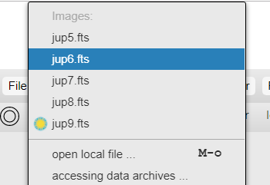
Switching Between Images

Click: File

The images currently loaded into JS9 will be listed at the top. Select the file you wish to view.

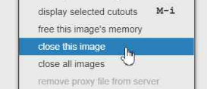
Closing Image(s)

One image (the top image) can be closed OR all images can be closed with just one click.

Click: File > close this image (or ‘close all images’)

Separating Images
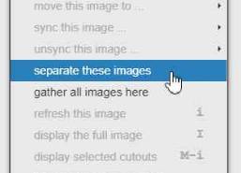
If you opened more than one image, you will only be able to view one at a time. Separating the images opens each image into a different JS9 window, stacked vertically in your browser. Once you separate your images, scroll down in your browser to view your other images.

Click: File > separate these images

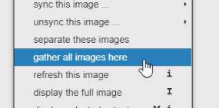
Gathering Images

Gathering images takes all images opened in JS9 and puts them all into one window. You can only gather all images with this command. To gather only specific images, see below.

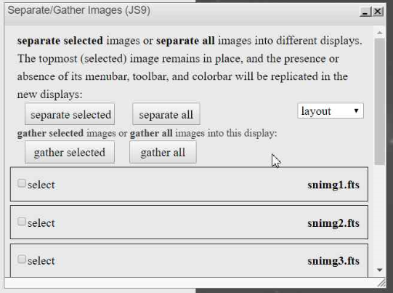
Gathering/Separating Specific/All Images
Click: View > Separate/Gather
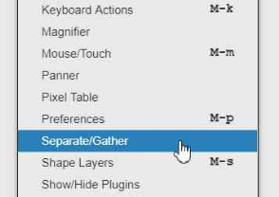
The pop-up box will allow the gathering and separation of individual images, selected groups or all images.

Syncing Images

The sync image options allows two or more images to be modified in the same way at the same time. Functions that can be used over multiple images include the ‘colormap’, ‘contrast’, ‘zoom’ and ‘regions’ features.

To Sync Images, they first must be separated (see instructions above).

Click: File > sync this image

Choose which image to sync with the current image or use the option at the bottom to choose ‘all images’.

Once sync’d images are adjusted, they can be ‘unsync’d’ individually or as a complete group in the same manner.

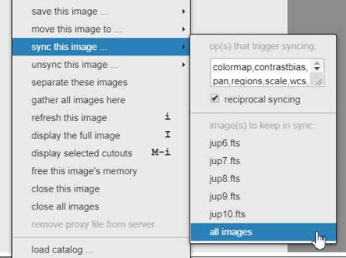

Magnifier Tool

The magnifier tool enlarges the image in a separate window to allow for more precise positioning and measuring.

- Click the ‘magnifier’ button on the toolbar to open the magnifier window.
- Move the magnifier window by dragging from its toolbar.
- The magnifier window will display the area around the mouse pointer as it moves over the image.
- The magnifier window can be easily moved as needed to view your main image.

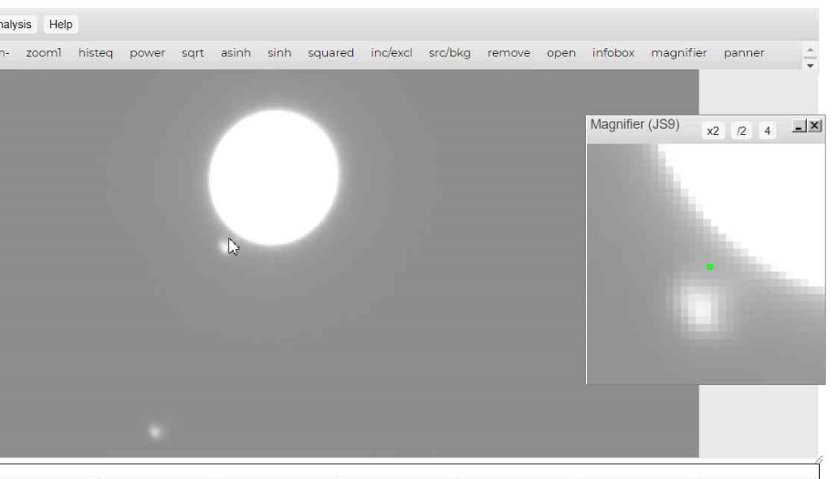

Regions (part of the image to be measured, including pixel distance)

Regions is the term JS9 uses to signify a selected area of an image. They are shown on the image in green and have a variety of shapes.

Regions can be selected from the toolbar or from the region drop down menu.
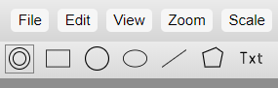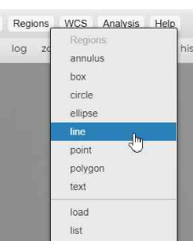

Regions can be:
- removed through the menu or by clicking on them, then hitting ‘delete’ on your keyboard.
- Moved, rotated, resized

To analyze a region,

Click: Analysis > Region Stats
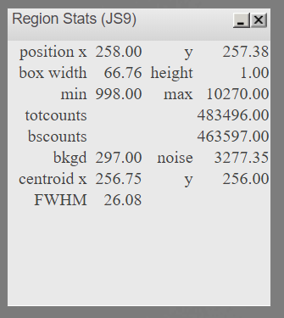
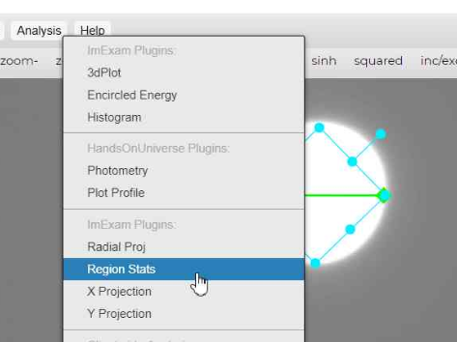

A region can be manipulated to help determine the meaning of the measurements in the ‘Region Stats’ box.

For the ‘line’ region, the ‘box width’ is the number of pixels across the line.

Pixel determination/location and intensity (green numbers in upper left of an image)

The green numbers in the upper left of the JS9 screen indicate, in order:
- Light intensity
- X-value location of pixels
- Y-value location of pixels

Note the numbers listed on the images below related to the location of the mouse pointer on the image.

Light intensity = 250 X = 198.750 Y= 304.750

Light intensity = 8029 X = 255.250 Y = 235.750

Light intensity = 377 X = 272.750 Y = 222.750

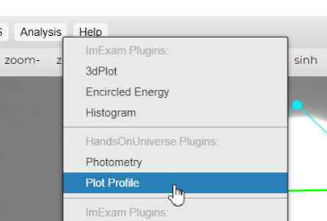
Region Analysis (Plot Profile, light intensity)

With a region selected,

Click: Analysis > Plot Profile

The ‘Plot Profile’ box that pops up shows the intensity of the image across the region highlighted (in this case, a line).

If you hover your mouse over the plot, crosshairs appear that give you the measurements of intensity and position (x/y locations) in the upper left corner. A green circle also appears on the region line (green line) on the image and indicates the position of the pixels within the image being analyzed.

This tool can be used to help determine the edges of objects. In this example, notice that the intensity drops dramatically in the graph on the outside edges of the region (line) because the line’s ends are placed beyond the bright part of the image.

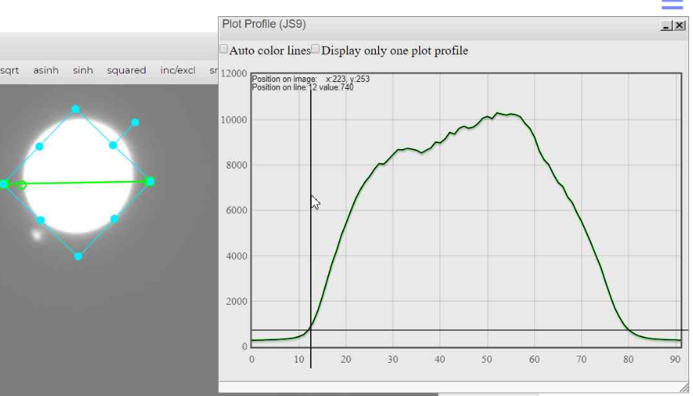

Blinking Function

The blinking function can be used to view multiple images in rapid succession. Blinking images can be cycled through manually or automatically.

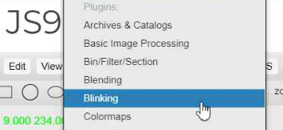
This function can assist in looking for differences between images, such as the motion of an object across the image field like an asteroid!

To use this function:
- Images should all be set to the same zoom and a workable contrast
- Images should be ‘gathered’ in the same JS9 window

Click: View > Blinking

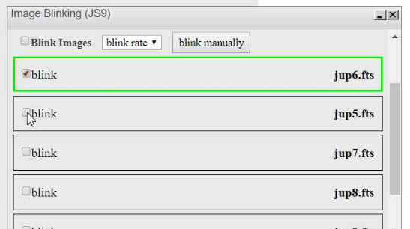
In the ‘Image Blinking’ box
- Check the boxes for the images you want to blink.
- Images can be rearranged by left-click-hold and dragging them up or down.
- Select ‘Blink Images’ to start the blinking of the images
  - The displayed image will be boxed in green in the ‘Image Blinking’ window.
- Click the ‘blink rate’ pull down menu to change the blink rate.
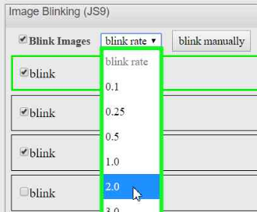
- To manually go through the images, uncheck ‘Blink Images’ and click ‘blink manually’ to cycle through the selected images

Blending Function

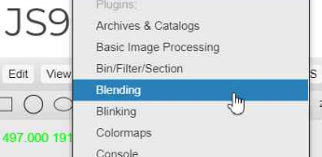
The blending function allows gathered (layered) images to be seen at the same time, with a user-selected amount of opacity. This function can be used to show the position of objects from different images on the same composite image to aid in measurements.

To use this function:
- Images should all be set to the same zoom and a workable contrast
- Images should be ‘gathered’ in the same JS9 window

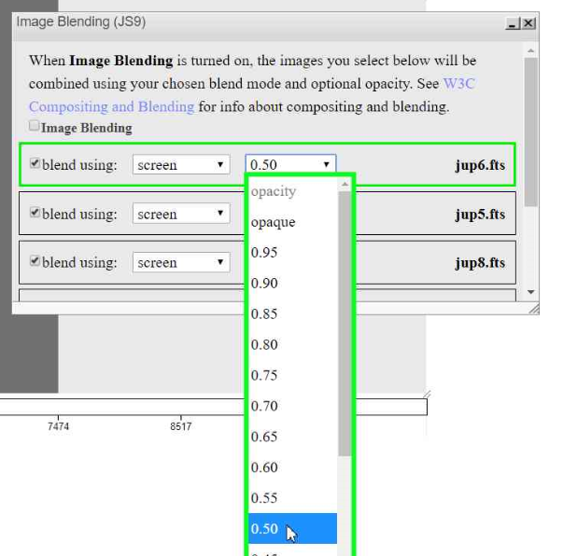
Click: View > Blending

- Select which images you want to blend by checking the boxes on the left
- Click on the ‘opacity’ dropdown menu and select the amount of the intensity for that image you wish to see in the blend.
- To blend the images, click the ‘Image Blending’ box.

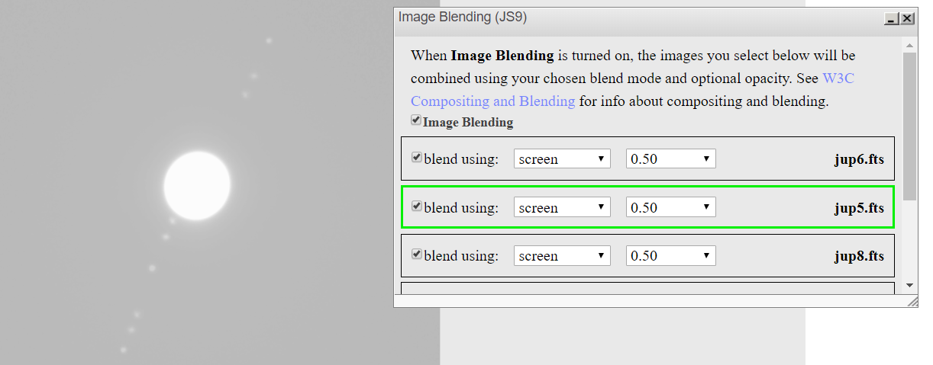
The image shown here is a blend of three images which show the different locations of the moons of Jupiter.

Add/Subtract Images (from each other) - Basic Image Processing

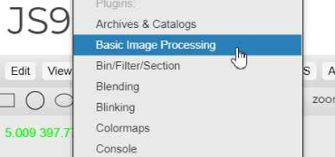
Adding or subtracting images from each other allows the user to notice the distinct differences between two or more images. It can also be used to layer (alternately add and subtract) multiple images to show a sequence of motion between images.

Before you begin, images should be:
- Zoomed to the same level
- Contrast adjusted
- Gathered to a single JS9 window

Click: View > Basic Image Processing

- Select the files you wish to add/subtract using the dropdown menus.
- Choose ‘Add’ or ‘Subtract’.
- The modified image will be created in a new JS9 window with the filename ‘AnonymousXX’ where ‘XX’ is a number.
- Those new files can then be added to or subtracted from by using the same procedure to create a composite image of multiple files.

***I prefer the blend option to create composites.
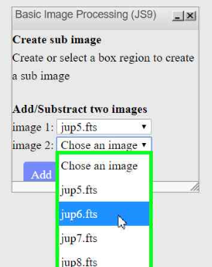

Apply Color (RGB), making a color composite

Color can be applied to images before blending to create a composite image based on red/green/blue filtered grays images. This creates a ‘colorized’ image.
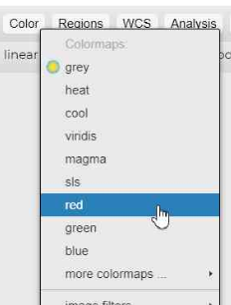
Before you begin, images should be:
- Zoomed to the same level
- Contrast adjusted
- Separated to different JS9 windows
- Unsync’d

- On the taskbar, open the dropdown menu ‘Color’, then select the color you wish for that image. Repeat this for your other images using the different colors as needed.
- Gather the images into on JS9 window.
- Use the blending feature to blend your selected images, adjusting the opacity to give your image the desired effect.

